Kubernetes Session Notes

Overview
If order management module fails then payment gateway also affected --> To fix we have Microservices
- Microservices – A software architecture where an application is broken down into small, independent services.
Follows Single Responsibility Principle
The Single Responsibility Principle (SRP) states that
a class or module should have only one reason to change, meaning it should have a single, well-defined responsibility
https://aws.amazon.com/microservices/
- Containers – A lightweight, portable way to package applications and their dependencies.
- Kubernetes – A container orchestration system to manage, scale, and deploy containerized applications.
- Helm – A package manager for Kubernetes, making deployments easier.
- Cloud – Cloud computing platforms like AWS, Azure, and GCP, which host and manage microservices and Kubernetes applications.

1️⃣ Microservices

🔹 What is Microservices Architecture?
- A system where an application is split into small, loosely coupled services.
- Each service handles one functionality and communicates with others via APIs.
- Example: An e-commerce app could have separate microservices for User Management, Orders, Payments, and Inventory.

🔹 Key Concepts
- Independence – Each service can be developed, deployed, and scaled separately.
- Resilience – If one service fails, others continue running.
- Scalability – Scale only the needed services (e.g., Payment Service during Black Friday).

🔹 Tech Stack
- Backend: Spring Boot (Java), Express (Node.js), FastAPI (Python), .NET
- Communication: REST API, gRPC, Messaging (Kafka, RabbitMQ)
- Database: MySQL, PostgreSQL, MongoDB (each microservice can have its own DB)
- Service Discovery: Eureka, Consul

2️⃣ Containers

🔹 What is a Container?
- A lightweight virtual environment that packages an application and its dependencies.
- Runs consistently across different environments (e.g., Dev, Test, Prod).

🔹 Why Containers?
✅ Avoids "It works on my machine" problems
✅ Faster startup than VMs
✅ Less resource usage

🔹 Key Tools
- Docker – The most popular container platform.
- Docker Compose – Helps define and run multi-container applications.
- Container Registry – Stores container images (Docker Hub, AWS ECR).

🔹 Example: Running a Node.js App in a Container
- Install Docker
- Create a Dockerfile
dockerfile
CopyEdit
FROM node:18
WORKDIR /app
COPY . .
RUN npm install
CMD ["node", "server.js"]
- Build and Run:
sh
CopyEdit
docker build -t myapp .
docker run -p 3000:3000 myapp

3️⃣ Kubernetes (K8s)

🔹 What is Kubernetes?
- A container orchestrator that automates deployment, scaling, and management of containers.

🔹 Why Kubernetes?
✅ Auto-scaling – Adds/removes containers based on traffic
✅ Self-healing – Restarts failed containers automatically
✅ Load balancing – Distributes traffic among services

🔹 Kubernetes Components
- Pod – Smallest deployable unit, contains one or more containers.
- Deployment – Defines how many replicas of a Pod should run.
- Service – Exposes a Pod to other services or the internet.
- Ingress – Routes external traffic to services.

🔹 Example: Deploying a Pod
yaml
CopyEdit
apiVersion: v1
kind: Pod
metadata:
name: my-pod
spec:
containers:
- name: my-container
image: nginx
Deploy it:
sh
CopyEdit
kubectl apply -f my-pod.yaml
kubectl get pods

4️⃣ Helm (Kubernetes Package Manager)

🔹 What is Helm?
- A package manager for Kubernetes to simplify deployment.
- Uses Helm Charts (pre-configured Kubernetes resources).
- Similar to apt/yum but for Kubernetes.

🔹 Why Helm?
✅ Easier management of complex apps
✅ Versioning for rollbacks
✅ Reusability – Share Helm Charts

🔹 Installing Helm
sh
CopyEdit
curl https://raw.githubusercontent.com/helm/helm/main/scripts/get-helm-3 | bash

🔹 Example: Installing Nginx using Helm
sh
CopyEdit
helm repo add nginx-stable https://helm.nginx.com/stable
helm install my-nginx nginx-stable/nginx-ingress

5️⃣ Cloud (AWS, GCP, Azure)

🔹 Why Cloud?
- Instead of running on your own servers, cloud providers handle infrastructure.
- Pay-as-you-go model.

🔹 Popular Services
- Compute: AWS EC2, Google Compute Engine, Azure VMs
- Kubernetes: AWS EKS, GCP GKE, Azure AKS
- Databases: AWS RDS, Firebase, CosmosDB
- Storage: S3, Google Cloud Storage, Azure Blob Storage

🔹 Example: Running Kubernetes on AWS (EKS)
- Create an EKS cluster:
sh
CopyEdit
eksctl create cluster --name my-cluster
- Deploy an app:
sh
CopyEdit
kubectl apply -f deployment.yaml

Gerrit ( Nokia uses this) is a code hosting platform like github

B to B --> “Business to Business (API Communication)”

B to C --> “Business to Customer (Gui Based)”

to send api request using terminal,
curl -X POST http://localhost:5001/api/users/create

MVC (Model-View-Controller) Architecture
MVC is a software design pattern used in web applications to separate concerns and organize code efficiently. It divides an application into three main components:
1️⃣ Model – Handles data and business logic
2️⃣ View – Manages the UI (User Interface)
3️⃣ Controller – Acts as an intermediary between Model and View

🔹 How MVC Works?
📌 The Controller receives a request from the user (e.g., clicking a button).
📌 It interacts with the Model to retrieve or update data.
📌 The View presents the data to the user in a structured format.
🔹 Flow Example:
- User requests a webpage (e.g., GET /profile).
- Controller handles the request (ProfileController).
- Model fetches data from a database (UserProfile).
- View displays the profile details (profile.html).

🔹 MVC Components in Detail

1️⃣ Model (Data Layer)
- Represents the application's data & business logic.
- Communicates with the database (e.g., MySQL, MongoDB).
- Example in Node.js (Mongoose Model):
javascript
CopyEdit
const mongoose = require('mongoose');
const UserSchema = new mongoose.Schema({
name: String,
email: String
});
module.exports = mongoose.model('User', UserSchema);

2️⃣ View (Presentation Layer)
- Handles how data is displayed to the user.
- Uses HTML, CSS, JavaScript, and templating engines like EJS, Handlebars, or React.
- Example in EJS (Express View):
html
CopyEdit
<h1>Welcome <%= user.name %>!</h1>
<p>Your email: <%= user.email %></p>

3️⃣ Controller (Logic Layer)
- Handles user requests and updates the Model & View.
- Acts as a bridge between Model and View.
- Example in Express.js Controller:
javascript
CopyEdit
const User = require('../models/User');
exports.getProfile = async (req, res) => {
const user = await User.findById(req.params.id);
res.render('profile', { user });
};

🔹 MVC Example in Different Frameworks
Framework | Model | View | Controller
Express.js (Node.js) | Mongoose (MongoDB) | EJS/Pug | Express Routes
Spring Boot (Java) | JPA/Hibernate | Thymeleaf | Spring Controllers
Django (Python) | Django ORM | Templates | Django Views
ASP.NET (C#) | Entity Framework | Razor Views | MVC Controllers

🔹 Why Use MVC?
✅ Separation of Concerns – Clean, modular code
✅ Reusability – Components can be reused easily
✅ Scalability – Better code structure for large applications

Docker uses Linux Namespaces, so containers can only run on Linux

“Containerd is alternative to docker”

minicube , ranger --> similar to k3s

Docker Now acquired by a company, so some parts of docker is paid ones

so companies are moving out of docker to containerd, podman(google product) etc...

Docker: A Comprehensive Overview
Docker is an open-source platform that enables developers to build, ship, and run applications in containers.
Containers are lightweight, portable, and self-sufficient environments that encapsulate everything needed to run an application, including code, runtime, libraries, and dependencies. This ensures that applications run consistently across different computing environments.

1. What is Docker?
Docker is a containerization platform that allows developers to package applications and their dependencies into standardized units called containers. Unlike traditional virtualization, which uses Virtual Machines (VMs), Docker shares the host OS kernel, making it faster, lightweight, and more efficient.

Why Docker?
- Portability – Works across different operating systems without modification.
- Efficiency – Uses fewer resources than virtual machines.
- Scalability – Easily scales applications using orchestration tools like Kubernetes.
- Consistency – Eliminates "works on my machine" issues.

2. How Docker Works
Docker operates on a client-server architecture with the following main components:

1️⃣ Docker Engine
- The core component of Docker.
- Runs on the host machine and manages containers.
- Consists of:
  - Docker Daemon (dockerd) – Runs in the background, managing images, containers, and networks.
  - Docker CLI (docker) – Command-line interface to interact with Docker.
  - REST API – Allows programmatic access to the Docker engine.

2️⃣ Docker Images
- A blueprint for containers.
- Contains the application, system libraries, and dependencies.
- Built using a Dockerfile.
- Stored in Docker Hub or private registries.

3️⃣ Docker Containers
- A running instance of a Docker image.
- Uses Linux namespaces and cgroups for isolation and resource control.
- Can be started, stopped, and deleted without affecting other containers.

4️⃣ Docker Registries
- Storage for Docker images.
- Public Registry: Docker Hub (default).
- Private Registries: AWS ECR, Google Container Registry, Azure Container Registry.

5️⃣ Docker Compose
- A tool to define and run multi-container applications using a docker-compose.yml file.
- Useful for microservices architecture.

3. Docker vs Virtual Machines
Feature | Docker (Containers) | Virtual Machines (VMs)
Startup Time | Milliseconds | Minutes
Resource Usage | Lightweight | Heavy (entire OS per VM)
Isolation | Process-level | Full OS isolation
Portability | High | Medium
Performance | Better | Slower due to overhead
🚀 Key Advantage: Containers are more efficient because they share the host OS kernel, while VMs require a separate OS for each instance.

4. Key Docker Concepts

🔹 Dockerfile
- A script containing instructions to build a Docker image.
- Example:
dockerfile
CopyEdit
FROM node:18
WORKDIR /app
COPY . .
RUN npm install
CMD ["node", "server.js"]

🔹 Docker Commands
- Build an image
sh
CopyEdit
docker build -t myapp .
- Run a container
sh
CopyEdit
docker run -p 3000:3000 myapp
- List running containers
sh
CopyEdit
docker ps
- Stop a container
sh
CopyEdit
docker stop container_id

5. Networking in Docker
Docker provides different networking options:
- Bridge Network – Default network for communication between containers.
- Host Network – Shares the host’s network stack.
- Overlay Network – Used in swarm mode for multi-host communication.
- None – No networking.
Example:
sh
CopyEdit
docker network create my_network
docker run --network=my_network myapp

6. Data Storage in Docker
Docker offers two types of persistent storage:
- Volumes – Managed by Docker.
sh
CopyEdit
docker volume create my_volume
docker run -v my_volume:/data myapp
- Bind Mounts – Maps a host directory into the container.
sh
CopyEdit
docker run -v /host/data:/container/data myapp

7. Docker Compose (Multi-Container Applications)
Docker Compose allows defining multi-container applications in a YAML file.

Example docker-compose.yml
yaml
CopyEdit
version: '3'
services:
web:
image: nginx
ports:
- "80:80"
db:
image: mysql
environment:
MYSQL_ROOT_PASSWORD: password
Start the application:
sh
CopyEdit
docker-compose up -d

8. Docker Swarm & Kubernetes

Docker Swarm
- Docker's native orchestration tool for managing multiple containers.
- Provides load balancing, scaling, and high availability.

Kubernetes (K8s)
- A powerful container orchestration tool.
- Used for auto-scaling, self-healing, and multi-node deployment.
- Kubernetes can manage thousands of containers efficiently.

9. Docker Security
Security is critical when using Docker. Best practices include: ✅ Use official images from trusted registries.
✅ Keep images updated to avoid vulnerabilities.
✅ Limit container privileges (--cap-drop=ALL).
✅ Use seccomp & AppArmor for additional security.
✅ Enable image scanning (docker scan myimage).

10. Docker in the Cloud
Docker is widely used in cloud environments, including:
- AWS (ECS, EKS)
- Google Cloud (GKE)
- Azure (AKS)
- DigitalOcean, Linode, etc.
Cloud providers offer Docker hosting, container orchestration, and managed Kubernetes services for scalability and reliability.

Conclusion
Docker revolutionized software development by making applications portable, lightweight, and efficient. It simplifies deployment, enhances scalability, and integrates well with Kubernetes and cloud services. Whether you're developing a microservices application or deploying software in a cloud-native environment, Docker provides the tools necessary for modern application

Kubernetes is an orchestrator (for managing containers)

Kubernetes will have Current state ans Desired State
Kubernetes will try to make the current state as same as Desired state

Kubernetes (other name of Kubernetes is K8s, coz there is 8 letters between k and s):

killercoda.com --> Online Kubernetes cli platform

For detailed Tutorials : https://kubernetes.io/docs/concepts

Additional Learning required:
kubernetes operators
custom resource defs
helm lifecycle
rest http rfc

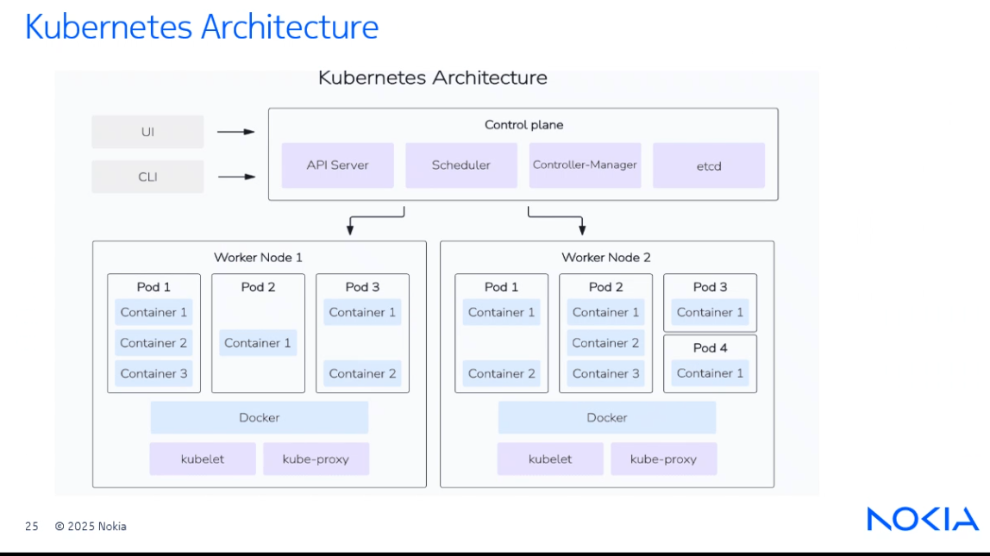
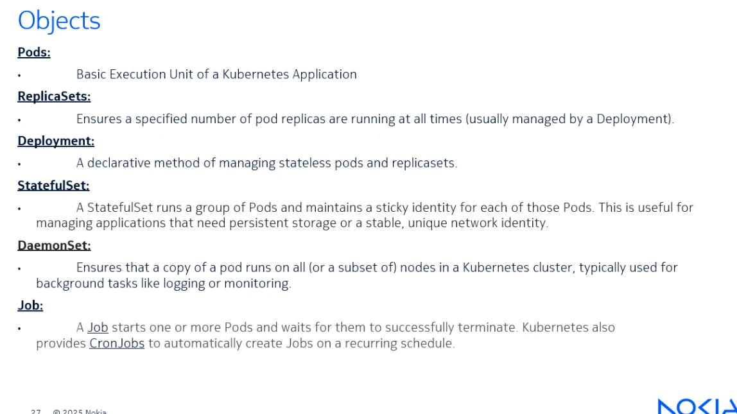

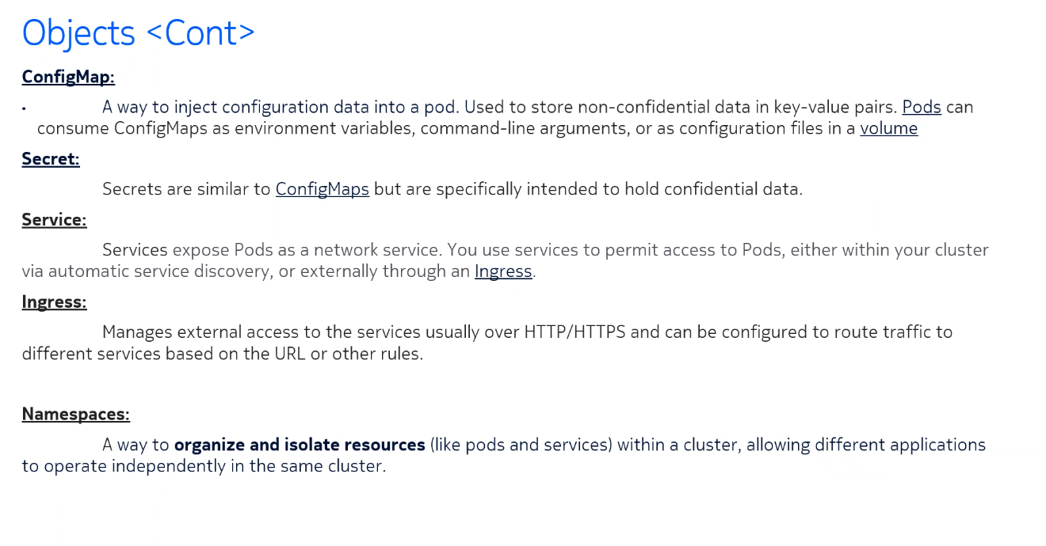

sudo kubectl create deployment nginx-ssn --image=nginx

kubectl get deployments

kubectl get pods

kubectl delete deployment --<name>

kubectl scale deployment nginx-ssn –replicas=2

kubectl delete pod <pod_id>

Feature | kubectl delete deployment | kubectl delete pod
Deletes? | Deployment + ReplicaSet + Pods | Only a single Pod
Pods recreated? | ❌ No | ✅ Yes (if managed by a Deployment)
Affects other Pods? | ✅ Yes (all Pods in the Deployment) | ❌ No (only the specified Pod)
Use Case? | Remove the entire app | Restart or troubleshoot a specific Pod

Final Verdict
- To remove the whole application: Use kubectl delete deployment <deployment-name>.
- To restart a Pod without affecting the application: Use kubectl delete pod <pod-name>.
kubectl get secrets

kubectl create ns ssn
# create a new namespace ssn with no resources

sudo kubectl create deployment nginx-ssn –image=nginx -n ssn
# create a deployment in ssn namespace
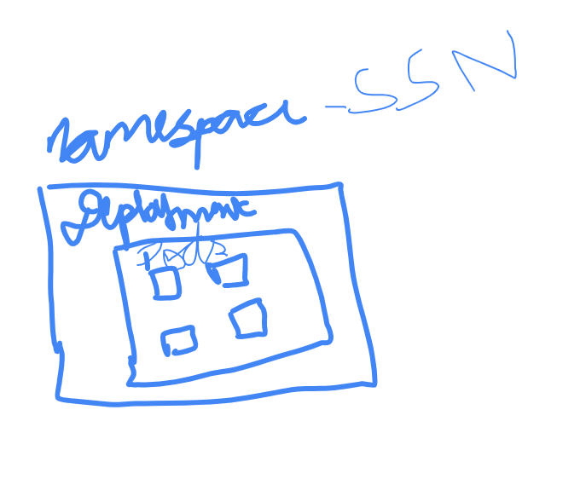
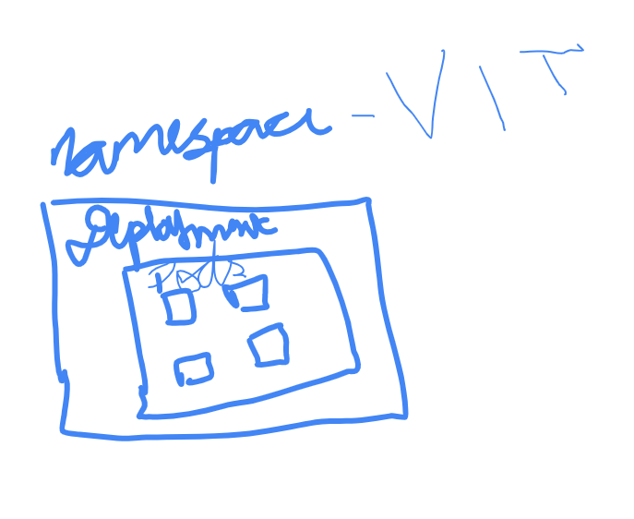

# Each pod will have its own IP address

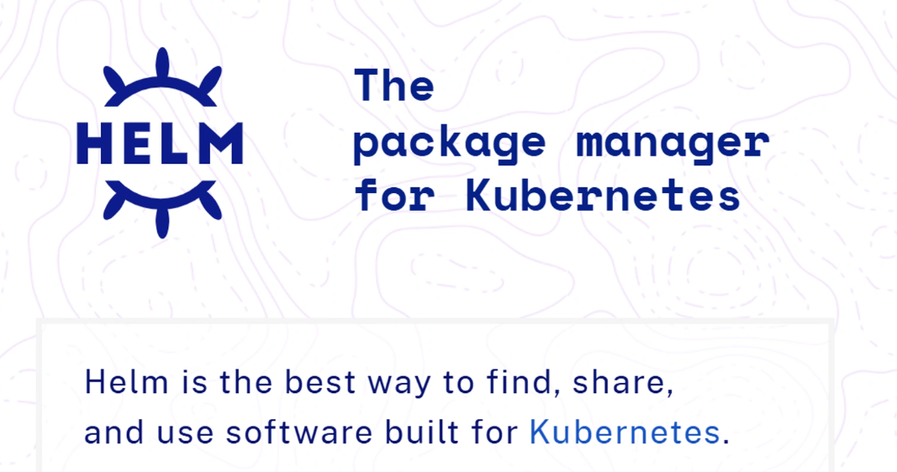

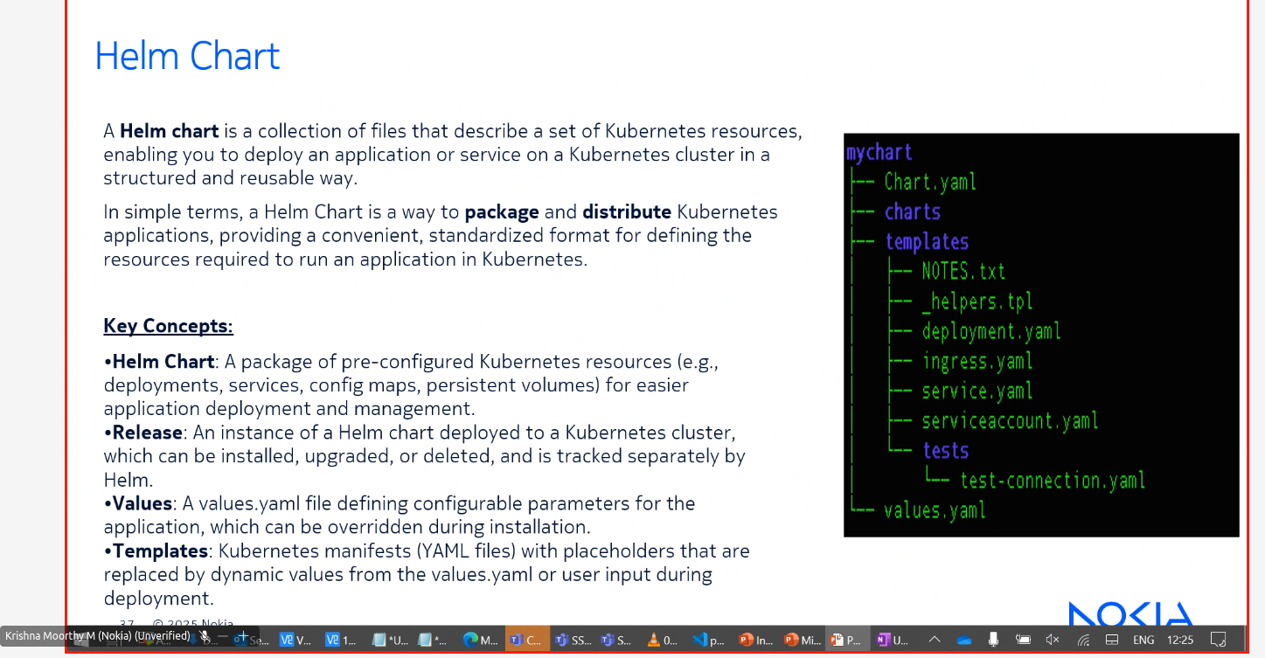
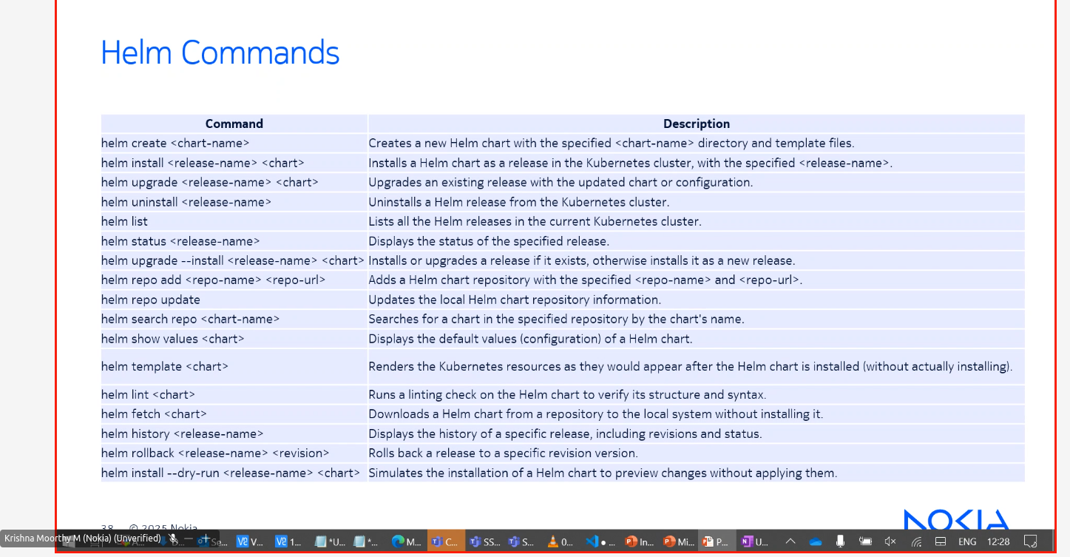

Info : “Most of the Resources of Netflixs is running in AWS almost 90% in aws”

AWS provides kubernetes as a service called “EKS”

EKS (Elastic Kubernetes Service) is AWS's managed Kubernetes service that allows you to run Kubernetes without managing the control plane. It simplifies deployment, scaling, and management of containerized applications.

🔹 Key Features of EKS:
- Managed Kubernetes: AWS handles the control plane, making maintenance easier.
- Integration with AWS Services: Works well with IAM, VPC, Load Balancers, CloudWatch, etc.
- Scalability: Supports autoscaling with EC2 or Fargate.
- Security: Integrated with IAM for authentication and offers encryption options.
- Multi-Region Availability: Supports high availability and disaster recovery.
Azure provides AKS (Azure Kuberntes Service)

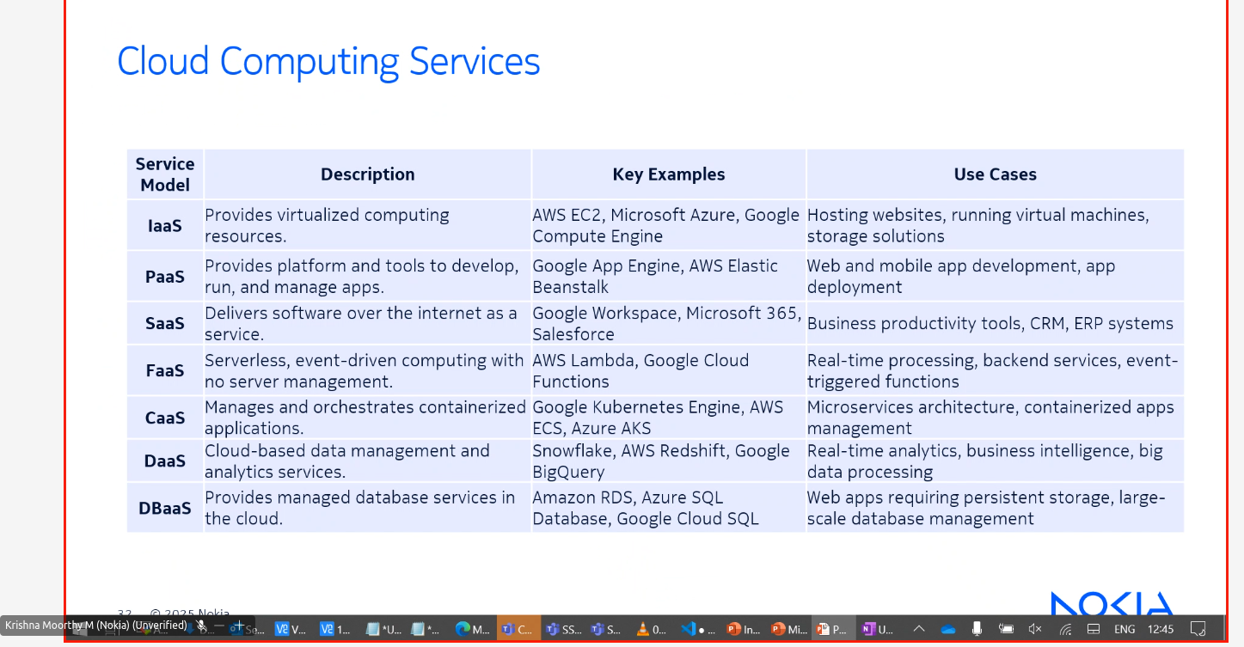

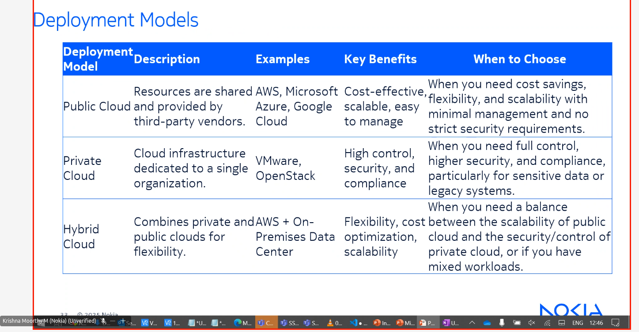

CronJobs are often used to clean up resources in Vms

